**The Potential of Clay Material as CO2 Capture Sorbent in the Pressure Temperature Swing Adsorption (PTSA) Process**

Wahid Ahmadi1 , * & Deni Shidqi Khaerudini1,2

1Postgraduate Master of Mechanical Engineering, Mercu Buana University, Jl. Meruya Selatan No. 1 Kembangan West Jakarta 11650

2Research Center for Advanced Materials, National Research and Innovation Agency (BRIN), Gd. 440 Puspitek Serpong Area, South Tangerang 15314, Banten

*Email: wahidfoundry@gmail.com

**Abstract.** The current state of increasing CO2 emissions is become challenging due to reduce emissions targeting policy. One of the processes of catching CO2 is pressure temperature swing adsorption (PTSA) with sorbent clay as an adsorbent material. The consideration of clay material is due to large availability in Indonesia and its CO2 adsorption potential capacity as good as the Zeolite 13X of 0.7 mol/kg. Pretreatment is required for bentonite to change its structure so that it increases its CO2 adsorption capacity. After going through the initial treatment process, the capacity adsorption CO2 of bentonite increases from 6 to 47 x 10-6 mol/kg due the changing of surface area and pore volume.

**Keywords:** CO2; capture; sorbent; emissions.

# Introduction

The earth's surface temperature has increased recently, this is due to the Greenhouse Gases (GHGs) accumulation from human and industries activities. GHG heat is retained in the atmosphere and contributes significantly to temperature rise and global warming [1, 2, 3]. GHGs dominated by CO2 gas by 83.83% and last a very long time in the atmosphere, only 50% can be absorbed by plants and oceans [4]. The rapid growth of global CO2 concentrations will also lead to the potential for an irregular climate and rising sea level levels that could threaten life at sea and most importantly the activity and survival of humanity [5]. CO2 emissions are generated from many sources such as the energy sector in power plants that use fossil-based fuels [6] as well as industries that produce exhaust gases such as the steel processing industry. Figure 1 taken from the 2018 Greenhouse Gas and MPV Inventory Report Ministry of Environment and Forestry of the Republic of Indonesia [10]. Shows a trend of increasing GHG emissions in Indonesia, every year it increases, especially in the energy sector in 2017 reaching 558,890 thousand tCO2e and in the industrial process and product uses (IPPU) sector reaching 55,395 thousand tCO2e. To overcome the increase of GHG emission, many approach already proposed, included Carbon Capture and Storage (CCS), Carbon Capture and Utilization (CCU), lower use burn fossil material and enforcement of clean and renewable energy [7, 8, 9].



1. Greenhouse gas emissions by sector type [10]

Therefore, CO2 capture technology has a very important role for the GHG gas reduction and climate change mitigation programs of the world. CO2 capture technology has various methods such as absorption, membrane, adsorption, and chemical looping as shown in Figure 2 [11].

CO2 capture technology is divided into three categories, namely pre-combustion, post combustion and Oxyfuel combustion [4]. Pre-combustion carbon capturing is most widely used in the production of mixed gases or called syngas, which contains mainly carbon monoxide and hydrogen. Carbon monoxide is separated from the mixture and converted into carbon dioxide, then obtained syngas raw materials used in chemical production and as thermal energy store. Oxyfuel combustion uses O2 gas which is purer than free air, with the aim of burning fuel that will produce exhaust gases containing CO2 and water vapor, then the exhaust gas is dehydrated to get CO2 gas. Post combustion carbon capture (PCC) focus on CO2 capture after the fossil fuel combustion process, usually in industry and power plants [4].

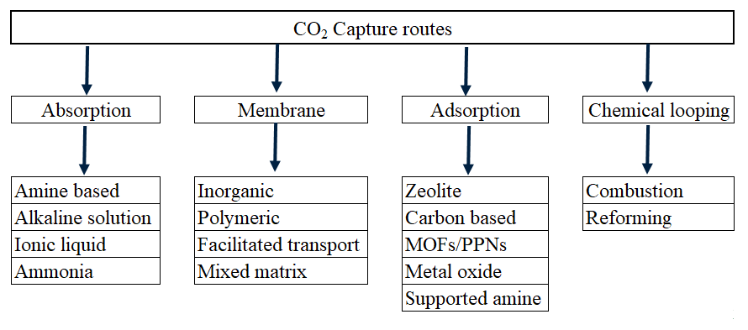

1. CO2 capture methods [11]

The capture and separation of liquid CO2 in an oxidant environment from the exhaust gases of a combustion system is called post combustion [12], one of the methods in post combustion is the adsorption method that is, the process by which molecules contained in a liquid or gas mixture stick to a solid surface, adsorbents. These molecules, even in small concentrations of flow, can be captured by this selective material. Properties of adsorbed particles (molecular size, molecular weight, and polarity) and adsorbent surface (polarity, pore size and distance) determine the quality of adsorption. The adsorption process is an exothermic process, the regeneration of adsorbents through desorption can be carried out by increasing temperature. However, when compared to the absorption method, the adsorption method uses lower energy. In the post combustion process, an adsorption method can be applied to capture CO2 from exhaust gases. Process of CO2 capture by adsorption method has been known to have advantages in terms of low investment costs and simple automation operations [13]. The best benefit of CO2 adsorption capture is the material regeneration facility by applying heat and/or vacuum. Generally, the power consumption of the Vacuum Temperature Swing Adsorption (VTSA) process for the capture of CO2 is lower than the absorption of chemicals such as MonoEthanolamine (MEA) solution [14]. Studies on the capture of CO2 adsorption are generally investigated from new adsorbents, simulations and experiments [15]. New adsorbent materials have been synthesized and tested experimentally, and the measurement indicators consist of: working capacity, breakthrough curves and adsorption isotherms [16, 17].

The CO2 capture process that uses the adsorption method is pressure temperature swing adsorption (PTSA), there are many sorbent materials that can be used such as activated carbon, zeolites, and metal organic frameworks (MOFs). In this study, we will review the characteristics of one type of clay material, namely zeolite as sorbent and other alternative clay materials in the proses of CO2 capture PTSA.

# Research Methodology

The method used in this study is the observation of literature from various sources, both journals and credible government report data. The literature data obtained from these various sources are then compiled for review on:

• Pressure temperature swing adsorption (PTSA) process flow.

• Characteristics of zeolite material in the PTSA process.

• Alternative clay material in the PTSA process.

# CO2 Capturing Process

## Pressure temperature swing adsorption (PTSA)

The PSA process is based on the adsorption of the desired gas (e.g., CO2) on porous adsorbents at high pressure, and gas recovery at low pressure. TSA is based on the adsorption of the desired gas at low temperatures and desorption at high temperatures. Thus, porous sorbents can be reused for subsequent adsorption. PSA technology is considered due to low energy requirements and low capital investment costs [18, 19]. The application of the PSA process to separate and capture CO2 is also being studied [20, 21, 22, 23]. The low recovery rate of CO2 is one of the problems reported on the PSA process. For the PSA process to be successful, the removable sorbent must have high selectivity, high adsorption capacity, and the adsorption and desorption rates for CO2 capture must be increased.

PTSA cycle steps are classified into two main groups: pressurization and feed are combined into the "adsorption" group, while depressurization, heating and cooling are grouped into the "desorption" group [13]. In Figure 3 shown you for the "adsorption" step, the treated exhaust gas is: it is taken to the compressor where the exhaust gas is compressed at high pressure. Then the compressed gas is fed to the adsorption column and the zeolite-like adsorbent reacts physically with carbon dioxide. The residual exhaust gases eventually radiate into the atmosphere. For the "desorption" step, CO2 is deposited in the heating column to increase the temperature and CO2 is then brought to the product line with a vacuum pump, it means that the column is maintained under atmospheric pressure. After heating and evacuation, the chamber is cooled to 303 o K, which is suitable for the adsorption of CO2 in subsequent cycles, with cooling water circulation. For all adsorption columns, the cycle steps are carried out alternately. Finally, the final gaseous product is compressed and transferred to the storage or usage location [13].

At room adsorption where happen process of adsorption gas exist sorbent material with purpose adsorb the gas that contained on gases then throw away to next process to release with pump vacuum thus generated product of CO2 [13].

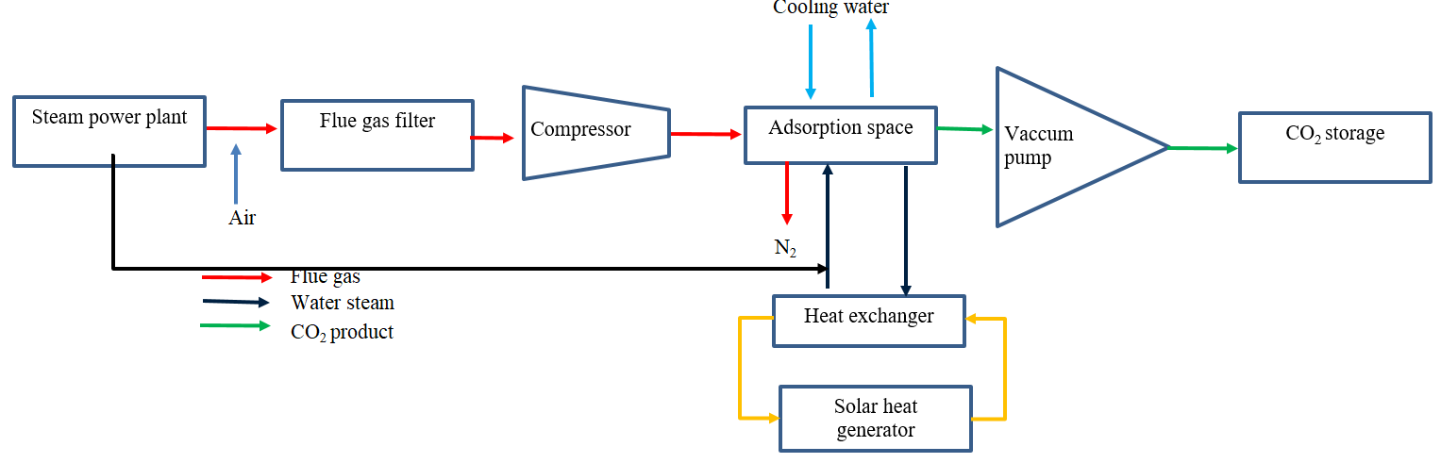

1. Integrated PTSA system with Coal Burning Power Plant

Figure 4 shows the stages of the process that occurs in the adsorption space:

Stages 1 – 2: the filling process with pressure so that the exhaust gases entering the room will increase. The sorbent material will draw CO2 and release N2.

Stage 2-3-4: evacuation and heating process where CO2 will be absorbed continuously by the vacuum pump and provide thermal energy up to a temperature of Tdes and Peva are balanced. Increase of temperature and decrease of pressure cause the desorption of the absorbed gas in the sorbent material.

Phase 4-1: cooling process by water, on this phase are not exist again gas left and cycle will recurring back to moment temperature room adsorption same with Tads[13].

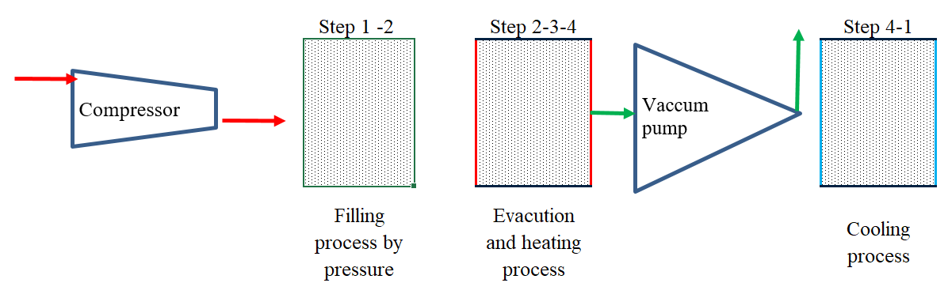

1. Stages in the PTSA cycle

## Characteristics of material sorbent zeolite

One of the sorbent materials that belongs to the clay group is zeolite. This material is a highly porous and highly economical mineral alumina silicate [24]. Based on zeolite-forming units, the zeolite skeleton can be divided into three. First, the primary forming units that are the tetrahedral units of SiO4 and AlO4. Secondly, a secondary unit that is a combination of primary forming units that bind to each other through a ring-shaped oxygen atom. Third, polyhedral building units are composed of several secondary forming units that form pores. The electric charge contained in the zeolite skeleton both on the surface and in the pore causes zeolite to act as a cation exchanger, adsorption, and catalyst. The water molecules in zeolite are molecules that are easily released by heating above 100 o C which results in the pores of the zeolite getting bigger. This state allows zeolite to adsorb molecules smaller than the midline of zeolite molecules [24]. Zeolite in a common shaped powder and usually to sorbent material used deep shape granule or Monolithic like in Figure 5.

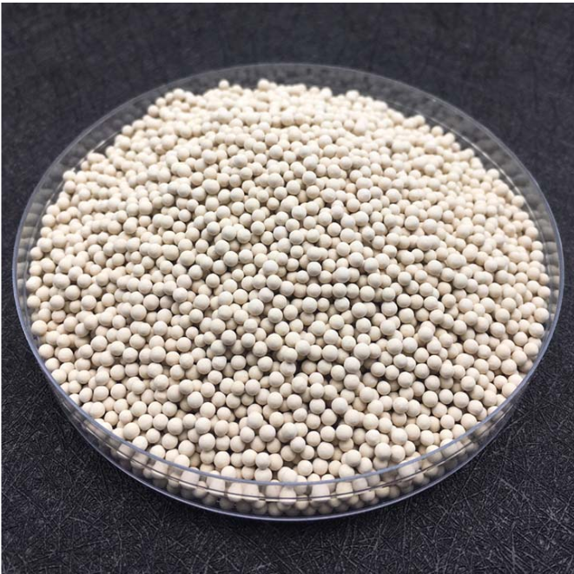

1. Granule zeolite 13X [25]

The basic properties of zeolite carried by cations allow for the strong capitation of acid molecules by increasing the density of the oxygen skeleton electron [26, 27]. This base strength increases by electro positives from the cation exchange [28]. More specifically, certain studies have shown that the basic strength of cationic zeolite containing Group 1A cations increases as follows: Li+ < Na+ < K+ < Rb+ < Cs+ [29, 30]

Another consideration in the selection of zeolite material is a strong CO2 adsorption affinity compared to N2, zeolite 13X has high adsorption capacity at low partial pressure for exhaust gases PCC. In addition, 13X zeolite is among the most widely used as physical adsorbents for capturing CO2 due to its low cost and profuse availability [31]. Zeolite shows promising results for the separation of CO2 from gas mixtures and can potentially be used in PSA processes. [ 20, 21, 22, 23, 32, 3 3,3 4]. According to the Energy Agency's (IEA) coal research report, the PSA/TSA system will be more energy efficient if the sorbent operates at moderate temperatures (125°C) or higher temperatures (325°C).

Based on studies that have been carried out, the characteristics that determine the ability of adsorption capacity are large pore diameter and large Na/Si ratio as well [35].

1. Physical properties of zeolite materials

|  |  |  |  |  |  |  |
| --- | --- | --- | --- | --- | --- | --- |
| **Properties** | **Zeolite type** | | | | | **Reference** |
|  | 13X | 5A | 4A | WE-G 592 | APG-II | [35] |
| Pore diameter (Ǻ) | 10 | 5 | 4 | 10 | 10 |
| Composition (weight %) |  |  |  |  |  |
| Na | 11,7 | 3,8 | 10,8 | 13,7 | 8,8 |
| Si | 18,2 | 16,7 | 16,1 | 16,5 | 14,3 |
| Na/Si | 0,64 | 0,23 | 0,67 | 0,83 | 0,62 |
| Adsorption capacity CO2 (mol/kg) | 0,7 | 0,38 | 0,52 | 0,60 | 0,38 |

Table 1 shows the properties of some zeolite materials where the results of the study show that the highest adsorption capacity can be achieved under the conditions of pore diameter and highest Na/Si ratio, namely in Zeolite 13X with pore diameter = 10 Ǻ, Na/Si = 0,64 and adsorption capacity CO2 = 0,7 mol/kg and Zeolite WE-G 592 with pore diameter = 10 Ǻ , Na/Si = 0,83 and adsorption capacity CO2 = 0,6 mol/kg [35].

With large pore diameter will make change process of cation Na+ easier happen, with the presence of cation Na+ will strengthen bond structure zeolite then make more endure on high temperature and absorb CO2 higher. While with smaller pore diameter exchange process of cation Na+ will more difficult thus make bond structure of zeolite will easy broken once applied higher temperature [35]. Shown in Figure 6 structure of zeolite A get change become structure B with the presence of change cation Na+ and next structure of zeolite become structure C then make better properties [35].

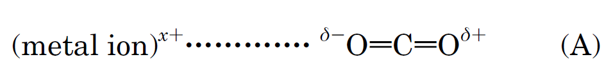

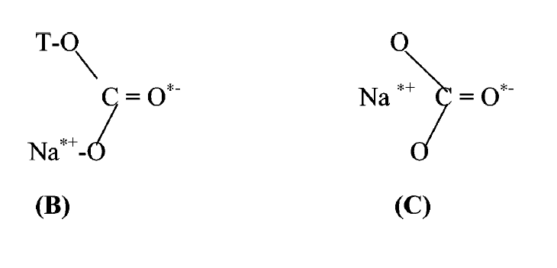

1. Zeolite structure in the changing process of Na+ cations [35]

## Alternative clay material in the PTSA process

Another type of clay material that has the potential to be used as sorbent material in the CO2 capture process is bentonite. Bentonite is a type of soft rock resulting from sedimentation from volcanic ash of volcanic eruptions and reacts naturally with minerals in the earth and its deposited millions of years. Due to its porous nature, bentonite can combine functions to form composite materials for adsorption, catalysis, and separation. One study reported adsorption and catalytic properties of bentonite layers with iron (Fe), chrome (Cr) and iron/chromium coatings with different Fe/Cr molar ratios [36]. This very soft rock consists of montmorillonite, a mineral clay type of phyllosilicate family formed from fine particles. Montmorillonite consists of two tetrahedral layers (SiO4) separated by an octahedral layer (Al (OH)6), its chemical formula is (Al, M2+)2 Si4O10 (OH)2, n H2O with M2+ = Mg, Fe (Figure 8) [37].

Bentonite also have shape basis powder with size mesh 200 or 75 microns but to Sorbent material usually deep shape granule like at picture 7.

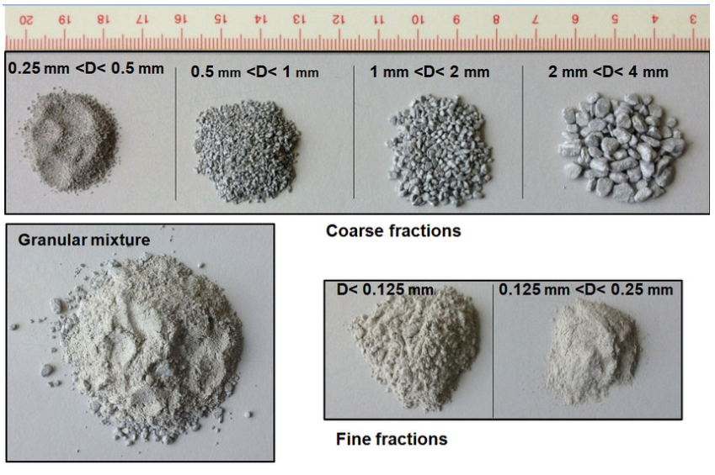

1. Bentonite granule [38]

Bentonite has a special place in water purification [39,40]. High specific surface area, chemical and mechanical stability, layered structure, high cation exchange capacity (CEC), tendency to retain water in its interlayer parts, and the presence of Brønsted and Lewis acidity have made clay an excellent adsorbent material [41, 42]. The chemical properties and pore structure of bentonite generally determine its adsorption ability [43, 44].

The adsorption properties of natural bentonite can be improved by several means such as the intercalation of organic, inorganic, or organometallic molecules in the interlamellar space, and by heat treatment or acidic [45, 46]. The applied method of increasing the adsorption capacity of bentonite consists of: the reaction of bentonite with a solution of strong acid, usually hydrochloric acid (HCl) or sulfuric acid (H2SO4). Acid activation leads to montmorillonite modifications with better properties such as increasing surface area, pore diameter, acid level, and catalytic activity. Natural treatment and montmorillonite treatment with hot mineral acids can replace cations with H+ ions. Gradual washing of Al3+ on both tetrahedral and octahedral parts, however the silicate group remains largely intact [47, 48].

The natural physical properties of bentonite are similar with zeolite only differ in pore diameter and CO2 adsorption capacity as shown in table 2 where bentonite has an adsorption capacity that smaller but along with the treatment of polyethyleneimine (PEI) material the adsorption capacity of CO2 increases [49].

1. properties of natural bentonite and after PEI treatment



According to the study above, it shows that natural bentonite has the lowest adsorption capacity compared to bentonite which has undergone a treatment process by PEI, the treatment process it changes the structure of bentonite thus changing the pore volume and producing a different adsorption capacity of CO2 [49].

Bentonite in addition to having natural pores, for the Calcium based type can be modified chemically to expand the cross-sectional area as to increase the adsorption ability of the gas. The chemical modification process is called the acid activation process, using a high concentration of sulfuric acid can change and open the bentonite layer so that the cross-sectional area is larger. Table 3 shows the influence of the activation results of H2SO4 acid which can open the pores of bentonite to be larger due to the dissolution of impurities in bentonite so that the area its specific cross section increases [50]. As in Figure 8 the structure of bentonite consists of impurities Al, Mg, Fe, OH and others, with the acid activation process then the impurities are dissolved and wasted [50].

1. Acid activation result data



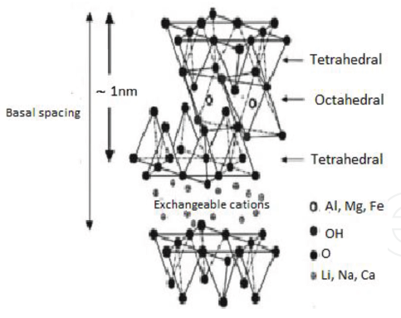

1. Bentonite structure [51]

# Conclusion

Based on the review information above then it can be taken that clay material is chosen as sorbent material in the PTSA process because of its good CO2 adsorption capacity as 6 to 47 x 10-6 mol/kg. CO2 adsorption capacity of bentonite will increase after going through pretreatment process to change its structure such as specific area and pore volume. Large pore diameter will give easier Na+ cation exchange process thus better thermal resistance and higher CO2 adsorption capacity.

# References

1. M, Mokhta, Z., Ong, MY., Salman, B., Nomanbhay, S., Salleh, SF., Chew, KW. Simulation Studies on Microwave-assisted Pyrolysis of Biomass for Bioenergy Production with Special Attention on Waveguide Number and Location. Energy. 190: 116474. 2020.
2. Antolini, D., Ail, SS., Patuzzi, F., Grigiante, M., Baratieri, M. Experimental Investigations of Air-CO2 Biomass Gasification in Reversed Downdraft Gasifier. Fuel. 253 :1473: 81. 2019.
3. Ma, Z., Liu, W., which, W., Li, W., Han, B. Temperature Effects on Redox Potentials and Implications to Semiconductor Photocatalysis. Fuel. 286(P2) :119490. 2021.
4. Zachary, L., Zhao, S., Matthew, A., Sam, T. Carbon Capture Materials and Technologies: A Review. Current Research in Materials Chemistry. 3(1): 108. 2021.
5. Qin, Y., Niu, G., Wang, X., Luo, D., Duan, Y. Status of CO2 Conversion Using Microwave Plasma. J CO2 Util. 28: 283–91. 2018.
6. Ideris, F., Shamsuddin, AH., Nomanbhay, S., Kusumo, F., Silitonga, USA. , Ong, MY. Optimization of Ultrasound-assisted O il Extraction from Canarium Odontophyllum Kernel as a Novel Biodiesel Feedstock. J Cleaner Prod. 288: 125563. 2021.
7. D, S, Alqarni. Ru-zirconia Catalyst Derived from MIL140C for Carbon Dioxide Conversion to Methane. Catalysis Today. 2020.
8. M, Biset-Peir ́o., J, Guilera., T, Zhang., J, Arbiol., T, Andreu. On the Role of Ceria in Ni-Al2O3 Catalyst for CO2 Plasma Methanation. Applied Catalysis A: General. 575: 223–229. 2018.
9. Hussin, F., Aroua, MK. Recent Trends in the Development of Adsorption Technologies for Carbon Dioxide Capture: A Brief Literature and Patent Reviews (2014–2018). J Cleaner Prod. 253: 119707. 2020.
10. Central Bureau of Statistics. "Greenhouse Gas and MPV Inventory Report, Ministry of Environment and Forestry of the Republic of Indonesia". (July 24, 2022). https://www.bps.go.id/statictable/2019/09/24/2072/emisi-gas-rumah-kaca-menurut-jenis-sektor-ribu-ton-CO2e-2001-2017.html
11. Ahmed, A. M., Anirudh, K., Ali, A. R., Fateme, R. Carbon Capture and Utilization Update. Energy Technology. 5: 1 – 17. 2017.
12. Ahmed, I. O., Mahmoud, H., Abdel, M., Ahmed, M. E., David, W. R. Recent Advances in Carbon Capture Storage and Utilisation Technologies: a Review. Environmental Chemistry Letters. 19: 797–849. 2021.
13. Ruikai, Z., Longcheng, L., Li, Z., Shuai, D., Shuangjun, L., Yue, Z., Hailong, L. Techno-Economic Analysis of Carbon Capture from a Coal-Fired Power Plant Integrating Solar-Assisted Pressure-Temperature Swing Adsorption (PTSA). Journal of Cleaner Production. 214: 440-451. 2019.
14. Wang, L., Liu, Z., Li, P., Yu, J., Rodrigues, A.E., Experimental and modeling investigation on post-combustion carbon dioxide capture using zeolite 13XAPG by hybrid VTSA process. Chem. Eng. J. 197: 151-161. 2012.
15. Chaffee, AL., Knowles, GP., Liang, Z., Zhang, J., Xiao, P., Webley, PA. CO2 Capture by Adsorption: Materials and Process Development. International Journal of Greenhouse Gas Control. 1:11-18. 2007. (Journal)
16. Lee, SY., Park, SJ. A Rreview on Solid Adsorbents for Carbon Dioxide Capture. J. Ind. Eng. Chem. 23:1-11. 2015.
17. Wu, B., Zhang, X., Xu, Y., Bao, D., Zhang, S. Assessment of the Energy Consumption of the Biogas Upgrading Process with Pressure Swing Adsorption Using Novel Adsorbents. J. Clean. Prod. 101: 251-261. 2015.
18. Skarstrom, CW. US Patent. No. 2,944,627. 1960.
19. Guerrin de Montgareuil, P., Domine, D. U.S. Patent. No. 3,155,468. 1964.
20. Cheu, K., Jong-Nam, K., Yun-Jong, Y., Soon-Haeng, C. Fundamentals of Adsorption: Proceedings of the Fifth International Conference on Fundamentals of Adsorption. Le Van, M. D., Ed., Kluwer Academic Publishers: Boston. 203-210. 1996.
21. Dong, F., Lou, H., Goto, M., Hirose, M. Purif Technol. 15:31-40. 1990.
22. Sircar, S., Golden, T. C. Ind. Eng. Chem. Res. 34: 2881- 2888. 1995.
23. Daeho, K., Siriwardane, RV., Biegler, LT. Ind. Eng. Chem. Res. 42:39-348. 2003.
24. DLHK banten province. "Zeolite Sa Adsorbent Logam Bclosely". (July 24,2022) https://dlhk.bantenprov.go.id/read/article/24/zeolit_sebagai_adsorben_logam_berat.html.
25. Jiangxi OIM Chemical Co., Ltd AL. "Product Adsorbents-MS Series". (July 24,2022) https://www.oimchem.com/adsorbents-ms-series/13x-apg-III-molecular-sieve.html.
26. Martra, G., Ocule, R., Marchese, L. Centi G and Coluccia S. Catal Today. 73:83. 2002.
27. Barthomeuf, D., Mallmann, A. Innovation in Zeolite Materials Science. Studies in Surface Science and Catalysis. 37. 1988.
28. Doskocil, E, J., Davis, R, J. J. Catal. 188: 353. 1999.
29. Huang, M., Kaliaguine, S. J. Chem. Soc. Faraday Trans. 88:751. 1992.
30. Tsuji, H., Yagi, F., Hattori, H. Chem. Lett.; 1881. 1991.
31. Chen, C., Park, DW., Ahn, WS. CO2 Capture Using Zeolite 13X Prepared from Bentonite. Appl. Surf. Sci. 292: 63-67. 2014.
32. Siriwardane, RV., Shen, M., Fisher, EP., Poston, JP. Energy Fuels. 15: 279-284. 2001.
33. Inui, T., Okugawa, Y., Yasuda, M. Ind. Eng. Chem. Res. 27: 1103- 109. 1988.
34. Akten, ED., Siriwardane, R., Sholl, DS. Energy Fuels. 17:977-983. 2003.
35. Ranjani, V. S., Ming-Shing, S., Edward, P. F. Adsorption of CO2 on Zeolites at Moderate Temperatures, Energy & Fuels. 19: 1153-1159. 2005.
36. F. Tomul. Adsorption and Catalytic Properties of Fe/Cr-Pillared Bentonites. Chemical Engineering Journal. 185 –186 (185): 380–390. 2012.
37. Suquet, H., de la Calle, C., Pezerate, H. Swelling and Structural Organization of Saponite. Clay Clay Miner. 23: 1-9. 1975.
38. Ali, S. Thermo-hydro-mechanical Characterisation and Modelling of Wyoming Granular Bentonite. Techinical report. 15-05: 35. 2015.
39. Arfaoui, S., Frini-Srasra, N., Srasra, E. Application of Clays to Treatment of Tannery S ewages. Desalination. 185: 419-426. 2005.
40. Hamdi, N., Srasra, E. Remove of Fluoride from Acidic wastewater by Clay Mineral Effect of Solid–liquid Ratios. Desalination. 206: 238-244. 2007.
41. Al-Asheh, S., Banat, F., Abu-Aitah, L. Adsorption of Phenol Using Different Types of Activated Bentonites. Sep. Purif. Technol. 33: 1-10. 2003.
42. Fu-Chuang, H., Jiunn-Fwu, L., Chung-Kung, L., Huang-Ping, C. Effects of Cation Exchange on the Pore and Surface Structure and Adsorption Characteristics of Montmorillonite. Colloid Surf. A: Physicochem. Eng. Aspects. 239: 41-47. 2004.
43. Min-Yu, T., Su-Hsia, L., Removal of Basic Dye from Water onto Pristine and HCl Activated Montmorillonite in fixed beds. Desalination. 194: 156-165. 2006.
44. Okada, K., Arimitsu, N., Kameshima, Y., Akira, N., Kenneth, MacKenzie, JD. Solid A cidity of 2:1 Type Clay Minerals Activated by Selective Leaching. Appl. Clay Sci. 31: 185-193. 2006.
45. Pinnavaia, T.J. Intercalated Clay Catalysts. Science. 220: 365-371. 1983.
46. Carrado, K, A. Synthetic Organoand Polymer-clays: preparation, characterization, and materials applications. Appl. Clay Sci. 17: 1-23. 2000.
47. Falaras, P., Kovanis, I., Lezou, F., Seiragakis, G. Cottonseed Oil Bleaching by Acid Activated Montmorillonite. Clays Clay Miner. 34: 221-232. 1999.
48. Hussin, F., Aroua, MK., David, WMAW. Textural Characteristics, Surface Chemistry and Activation of Bleaching Earth: a Review. Chem. Eng. J. 170: 90-106. 2011.
49. Chao, C., Dong, WP., Wha, SA. Surface Modification of a LowCost Bentonite for Post-Combustion CO2 Capture. Applied Surface Science. 283: 699– 704. 2013.
50. Khoirina, D. N., Dian, M. W., Daryani, Y. H. Kajian A activation H2SO4 Terhadap Proses Pemilaran Al2O3 Pada Lempung Alam Pacitan, ALCHEMY Journal of Chemical Research. 12 (2): 190 – 203. 2016.
51. Reda, M., Nacer, D., Nadia, B., Fatima, O., Faiza, Z. Study of Adsorption Properties of Bentonite Clay. Intech Open. 978-1-83968-604-7: 2. 2021.