Flood Hazard Assessment in Kalinyamatan District Generated by Dam Break of Bakalan Dam in Jepara Regency

Tania Sinayangsih^{1,2, *}, Eka Oktariyanto Nugroho ¹ & Agung Wiyono Hadi Soeharno²
¹ Magister Study Program of Water Resources Management, Civil Engineering Study Program, Faculty of Civil and Environmental Engineering, Bandung Institute of Technology, Bandung 40135, Indonesia
²Water Resources Engineering Research Group, Civil Engineering Study Program, Faculty of Civil Engineering and Environmental, Bandung Institute of Technology, Bandung 40135, Indonesia
*Email: nayangg97@gmail.com

Abstract. Bakalan Dam is one of the dams planned to be built on the Bakalan River, Jepara Regency. This dam is designed to meet the needs of raw water, irrigation needs also flood control. Bakalan Dam not only has great benefits in controlling floods, and meeting raw water and irrigation needs, but also harbors potential hazards. With a height of up to 87 meters due to being built between extreme slopes, if the dam collapses, it can cause large losses of life and material loss. The collapse of this dam can be caused by overtopping, where water with a large discharge can no longer be flowed by the spillway, and flows over the top of the dam. The analysis was carried out using HEC RAS ​​2D and GIS, it is shown that Kalinyamatan District will be the one heavily affected by the collapse of Bakalan Dam. Through HEC RAS 2D, author can also determine the risk of flood inundation, speed of arrival of water, and arrival time of water in the affected area. Therefore, to avoid casualties, a map of the potential risk for dam collapse due to overtopping is planned. It is hoped with risk mapping, it can increase awareness of affected areas by estimating material losses and affected people.
Keywords: Dam Break Analysis; Dam; Risk Map; Overtopping; HEC-RAS; Hazard Map; Vulnerability Map; Capacity Map; Jepara.

Introduction
The Bakalan Dam is one of the dams planned to be built over the Bakalan River, Mount Muria, Jepara Regency. The Bakalan Dam is designed to meet the needs of raw water, irrigation water, and flood control. It is recorded that Jepara Regency does not yet have optimal coverage of drinking water and sanitation, until 2016 the percentage of households with access to proper raw water reached 80.73% and the percentage for IPLT services was 0.0056%. This is still far from the Ministry of Public Works and Public Housing 100-0-100 Program in 2019 where the target is 100% access to drinking water, 0% slum areas, and 100% access to proper sanitation given by Regional Regulation of Jepara Regency in [1]. It was also noted that the condition of the irrigation network was not yet optimal. It is marked by the ratio of irrigation networks in good condition to new cultivation areas reaching 9.82 m/ha. The percentage of irrigation canals in good condition only reached 25.57% in 2016. The things above show that the availability and access to raw water and irrigation networks are still limited and far from the program target of the Ministry of Public Works and Public Housing given by Regional Regulation of Jepara Regency in [1]. Therefore, the Bakalan Dam is planned to be built where the benefits of the Dam are to meet the needs for raw water, irrigation needs, and flood control.
In general, dams not only save enormous potential benefits for humans but also carry risks, a namely sudden collapse which can cause many casualties and material losses downstream given by Che Ros F, et.al in [2]. The types of collapse scenarios that are often associated with dam failure cases are overtopping and piping. The actual number of cases of runoff and pipeline failure is dominant at 70.9% and 14.3%, respectively, usually this runoff water has a large discharge and high water velocity given by Sammen, S.S, et.al in [3]. Overtopping occurs when the uncontrolled flow of water goes beyond the top of the dam. The flow is the same as the flow that passes through the top of the dam body, where erosion occurs downstream of the dam and widens to the top of the dam which causes the dam to collapse given by Shahrim, M. F, et.al in [4]. Therefore, dam failure due to overtopping is unavoidable.
In calculating dam failure, several models and calculations can be found in related literature given by Cannata, M, et.al [5], Gogoaşe Nistoran, D. E, et.al in [6], Álvarez, M., et.al., in [7], Nabilah, R.A., et.al. in [8] and Pratiwi V., et.al., in [21]. Apart from that, this dam modeling also uses some software which is increasingly diverse in form and approach as well as what can be displayed in certain software, one of which is the famous HEC-RAS software given by HEC-RAS Manual in [9], where this software can also be found in several works of literature given by Torimtubun A.T, et.al I [10], Pramono A, et.al in [11], Muammar, A. Z, et.al., in [12], Palar, R.T, et al, in [13] and Balogun, O.S, et. al in [14] and Sandi, C., et. al [15]. In this study, the supporting software for modeling and calculating dam failure is HEC-RAS.
Therefore in this case, not only the calculation of the dam collapse, but preventive studies related to the risk of dam collapse caused by malfunctions and lack of management procedures during an emergency are very important given by De Moel, H et.al in [16] and Pu, J.H., et.al in [17]. Thus, the creation of disaster maps for affected areas is very important and a part of dam break calculations to better understand, mitigate and manage these risks given by Albano, R., et al., in [18].

Study Area
The Bakalan Dam was built on the Bakalan River and according to HEC RAS 2D, the Bakalan Dam collapse had the most severe impact on the Kalinyamatan District, Jepara Regency, Central Java Province, Indonesia. Figure 1 showed Jepara Regency area with each District.
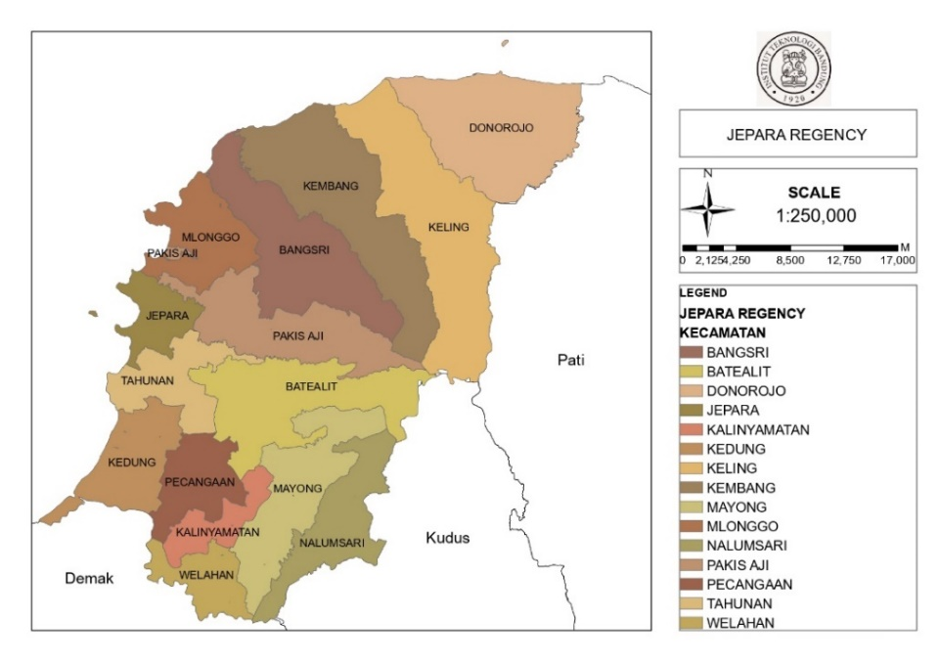
Figure 1 Study area, kalimanyatan district
Kalinyamatan district is located at 6º 43' 42" latitude, 110º 42' 48" east longitude is one of the districts in Jepara regency, Central Java province, Indonesia. There are 12 villages in the district which has an area of 24.2 km². Kalinyamatan district itself has a population of ± 62,550 people, with the majority of the population working as farmers and laborers shown in Figure 2. [19]
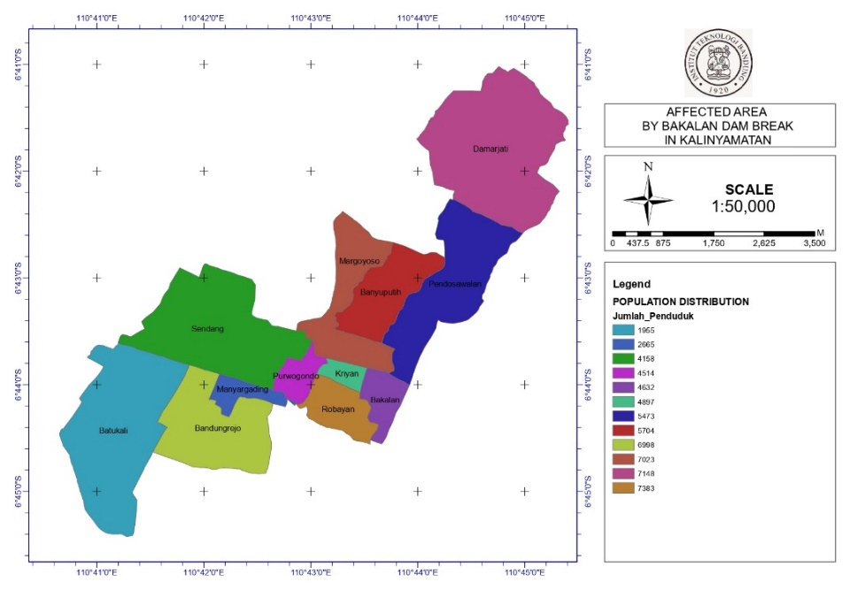
Figure 2 Population distribution in kalimanyatan district
Kalinyamatan district is mostly residential, agricultural, and rice fields. Several industries and factories are also developing in Kalinyamatan District including the Cigarette Factory, Brown Sugar Industry, and others shown in Figure 3. [19]
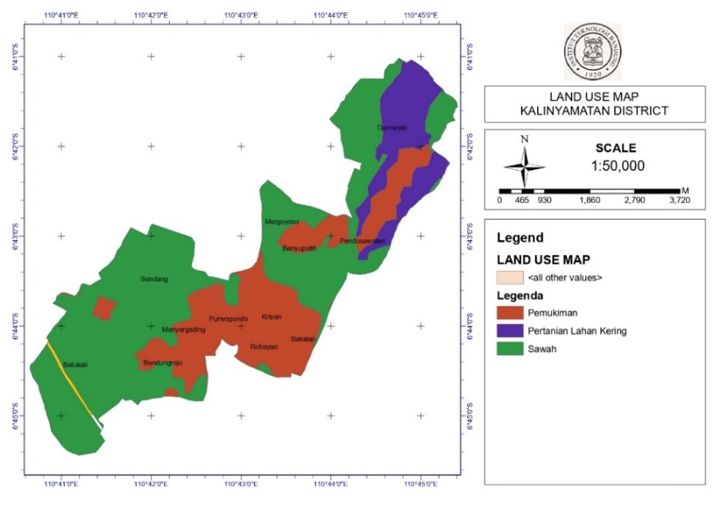
Figure 3 Land use in kalimanyatan district

Therefore, if Bakalan dam break disaster occurs, the Kalinyamatan district could potentially be inundated by flooding caused by the collapse of the Bakalan Dam.

Methodology
There are three steps in this study to decide the risk map in result of Dam Break Analysis.
- Dam Break Analysis
- Risk Mapping Area
- Hazard map
- Vulnerability map
- Capacity map

Dam Break Analysis
Dam Break analysis using HEC RAS 2D program. HEC-RAS is an integrated system of software, designed for interactive use in a multi-tasking, multi-user network environment. The HEC-RAS system contains four one-dimensional hydraulic analysis components for: (1) steady flow water surface profile computations; (2) unsteady flow simulation; (3) movable boundary sediment transport computations; and (4) temperature and water quality constituent transport modeling. A key element is that all four components use a common geometric data representation and common geometric and hydraulic computation routines. In addition to the four hydraulic analysis components, the system contains several hydraulic design features that can be invoked once the basic water surface profiles are computed. [9]

Risk Mapping Area
The risk mapping was taken from the 2D HEC RAS results and will be plot in Arc GIS. Using the Arc GIS program, the affected area will be shown. From that, we can plot the area onto Arc GIS program to get risk map which consist hazard map, vulnerability map, and capacity map.
Using Regulation of the Head of the National Disaster Management Agency No. 02 of 2012 concerning General Guidelines for Disaster Risk Assessment to determined the Indicator for Risk Mapping. [20]

Result and Discussion

Dam Break
In calculating the dam break process, some data has been processed beforehand, such as planned flood discharge data, QPMF data, reservoir data, river flow data, dam hydraulics data, and others. The following are the results of processing the initial data before calculating the Dam Break by HEC RAS 2D.

Dam Break Analysis
In dam break analysis, the first thing to do is to create Layers and Contour Maps using Arc GIS. After the contour and layer maps have been obtained, the Dam Break process can be continued on HEC RAS 2D. After getting the appropriate contour map, continue the dam break process using HEC RAS 2D. The following are the results of the Bakalan Dam running dam break from HEC RAS 2D shown on Figure 4.
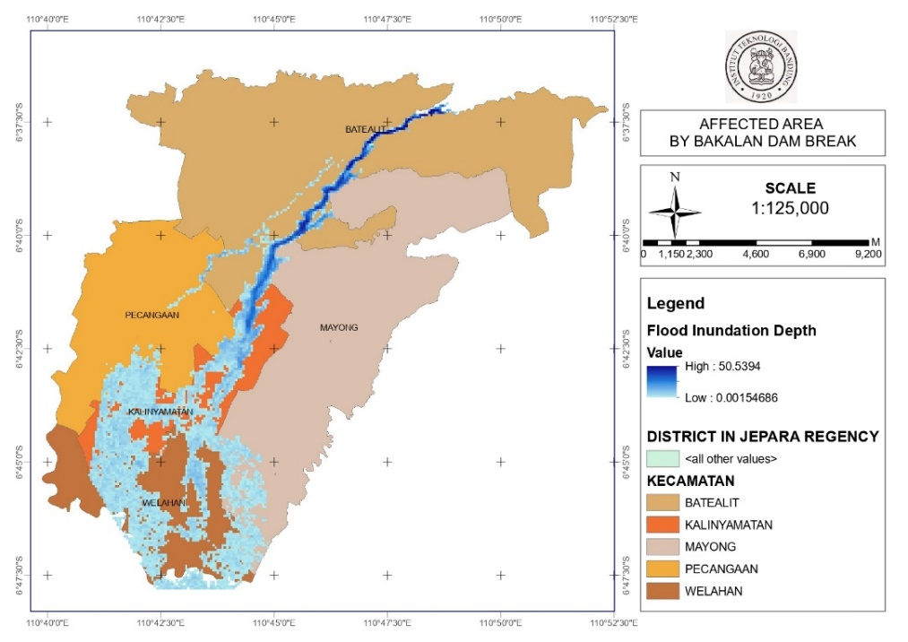
Figure 4 Affected area by bakalan dam break

Risk Mapping Area
Based on Regulation of the Head of the National Disaster Management Agency No. 02 of 2012 concerning General Guidelines for Disaster Risk Assessment, risk mapping area consists of hazard map, vulnerability map and capacity map, which combined to get risk mapping area.

Hazard mapping area
Hazard map is calculated based on Meteorology, Climatology, and Geophysical Agency and Ministry of Public Works and Public Housing. Hazard level for flood risk shown on Table 1.
- Disaster threat index component.
No | Disaster | Index | Index Level |  |  | Total
1 | Flood Risk | Zoning Map of Flood Areas | Low | Moderate | High | 100 %
 |  |  | < 1m | (1-3m) | > 3m

From HEC RAS 2D analysis, depth of the flood in Kalinyamatan district can be seen through Figure 5. It can be seen through hazard map that flood inundation depth varies from 1-4 meters. Therefore, hazard score can be calculated shown in Table 2.
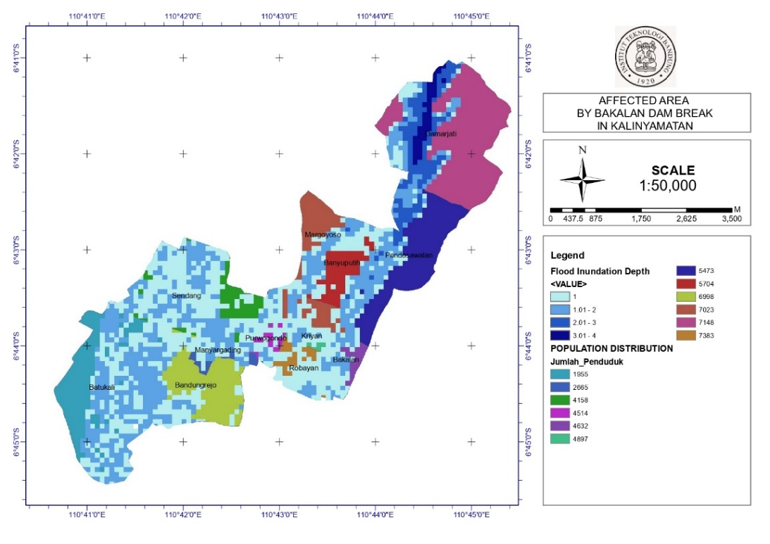
Figure 5 Affected area by bakalan dam break in Kalinyamatan.

It can be seen through hazard map that flood inundation depth varies from 1-4 meter. Therefore, hazard score can be calculated shown in Table 2.

- Hazard score per sub-district in Kalinyamatan District.
No | Sub-District | Depth Max  (meters) | Level | Score
1 | Kriyan | 2 | Moderate | 0.6667
2 | Bandungrejo | 2 | Moderate | 0.6667
3 | Pendosawalan | 4 | High | 1
4 | Margoyoso | 2 | Moderate | 0.6667
5 | Batukali | 2 | Moderate | 0.6667
6 | Robayan | 2 | Moderate | 0.6667
7 | Purwogondo | 2 | Moderate | 0.6667
8 | Banyuputih | 3 | Moderate | 0.6667
9 | Manyargading | 2 | Moderate | 0.6667
10 | Darmajati | 4 | High | 1
11 | Sendang | 2 | Moderate | 0.6667
12 | Bakalan | 2 | Moderate | 0.6667

Vulnerability Map
Vulnerability map is calculated based on social vulnerability, economic vulnerability, physical vulnerability, and environmental/ecological vulnerability.
The calculation of the vulnerability score of an affected area is based on the Social Vulnerability Indicator (Regulation of the Head of the National Disaster Management Agency No. 02 of 2012 concerning General Guidelines for Disaster Risk Assessment). The following vulnerability scores are divided into social, economic, physical, and environmental vulnerabilities as follows:
Economic Vulnerability: using the indicators of Productive Land and Gross Regional Domestic Product [20] for the Kalimanyatan district as follows are shown in Table 3.
- Economic vulnerability.
Parameter | Weight | Value |  | Class | Score | Total Score
 |  | Numbers | Percentage
Productive Land | 60% | Rp25,865,317 | 13% | High | 0.22 | 0.13
Gross Regional Domestic Product | 40% | Rp21,944,232 | 7% | Low | 0.18 | 0.11
Economic Vulnerability |  |  |  |  |  | 0.24

Physical Vulnerability: using indicators of housing, public facilities and critical facilities [20] for the district of Kalimanatan as follows are shown in Table 4.

- Physical vulnerability.
Parameter | Weight | Value |  | Class | Score | Total Score
 |  | Numbers | Percentage
Housing | 40% | Rp. 575,000,000 | 72% | High | 0.56 | 0.22
Public facilities | 30% | Rp. 750,000,000 | 75% | Moderate | 0.40 | 0.12
Critical Facilities | 30% | Rp. 750,000,000 | 75% | Moderate | 0.40 | 0.12
Physical Vulnerability |  |  |  |  |  | 0.46

Environmental Vulnerability: using the indicators of Protected Forests, Natural Forests, Mangroves, Shrubs and Swamps [20] for the Kalimanyatan district as follows are shown in Table 5.

- Environmental vulnerability.
Parameter | Weight | Value |  | Class | Score | Total Score
 |  | Numbers | Percentage
Protected forest | 30% | 0 | 0% | Low | 0.00 | 0
Natural Forest | 30% | 0 | 0% | Low | 0.00 | 0
Mangrove forest | 10% | 0 | 0% | Low | 0.00 | 0
Shrubs | 10% | 0 | 0% | Low | 0 | 0
Swamp | 20% | 0 | 0% | Low | 0 | 0
Environmental Vulnerability |  |  |  |  |  | 0

Social Vulnerability: using the indicators of Population Density, Sex Ratio, Poverty Ratio, Ratio of People with Disabilities, and Age Group Ratio [20] for the district of Kalimanyatan as follows are shown in Table 6.

- Social vulnerability.
Parameter | Weight | Value |  | Class | Score | Total Score
 |  | Numbers | Percentage
Population Density | 60% | 2399 | 60% | High | 1.00 | 0.60
Gender Ratio | 10% | 9.80% | 24% | Moderate | 0.98 | 0.10
Poverty Ratio | 10% | 7.44% |  |  | 0.74 | 0.07
Disabled Person Ratio | 10% | 0.32% |  |  | 0.03 | 0.00
Age Group Ratio | 10% | 6.25% |  |  | 0.63 | 0.06
Social Vulnerability |  |  |  |  |  | 0.84

Therefore, the value of the vulnerability score of the Kalinyamatan area in the face of flood disasters due to the dam break will be as follows:
Flood Vulnerability: (0.4 * Social Vulnerability Score + 0.25 * Economic Vulnerability Score + 0.25 * Physical Vulnerability Score + 0.1 * Environmental Vulnerability Score) [20]
The result of flood vulnerability for Kalimanyatan district is 0.51
After getting the results of the flood vulnerability score, the results were then plotted into a GIS arc and succeeded in getting a vulnerability map of the Kalimanyatan district consisting of 12 villages are shown in Figure 6.
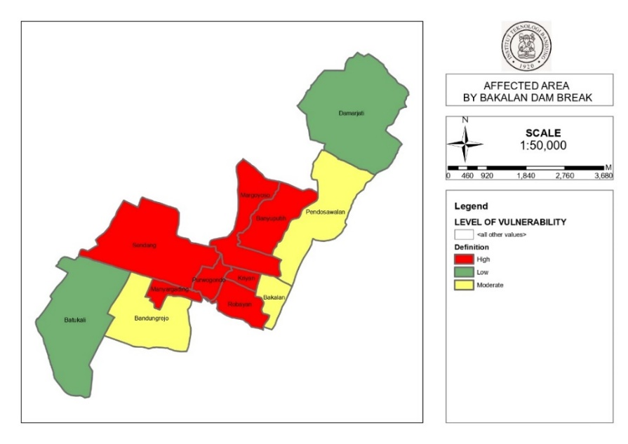
Figure 6 Vulnerability map in kalimanyatan district.
It can be seen on the map, 3 villages have moderate vulnerability, while 2 villages have low vulnerability, but 7 villages have high vulnerability when the flood disaster due to the dam collapse occurred.

Capacity Map
The calculation of the capacity map is based on the ability of the region and the community to take actions to reduce threats and potential losses due to disasters in a structured, planned, and integrated manner. In the case of the affected area, namely Kalinyamatan District, Jepara Regency, according to several articles, an annual disaster mitigation socialization has been held in several sub-districts in Jepara, but not yet in its entirety. Therefore, according to Regulation of the Head of the National Disaster Management Agency No. 02 of 2012 concerning General Guidelines for Disaster Risk Assessment [20], capacity map calculates the capacity available at the area to recover from certain disasters, where some of the components of the capacity index are shown on Table 7. [15]

- Capacity Index
No | Parameter | Max Value (%) | Existing Value | Score
1 | Disaster Management Rules and Institutions | 15 | 15% | 0.15
2 | Early Warning and Disaster Risk Assessment | 15 | 15% | 0.15
3 | Disaster Education | 20 | 10% | 0.10
4 | Basic Risk Factor Reduction | 25 | 10% | 0.10
5 | Preparation Development at All Lines | 25 | 15% | 0.15
 | Total Score |  |  | 0.65
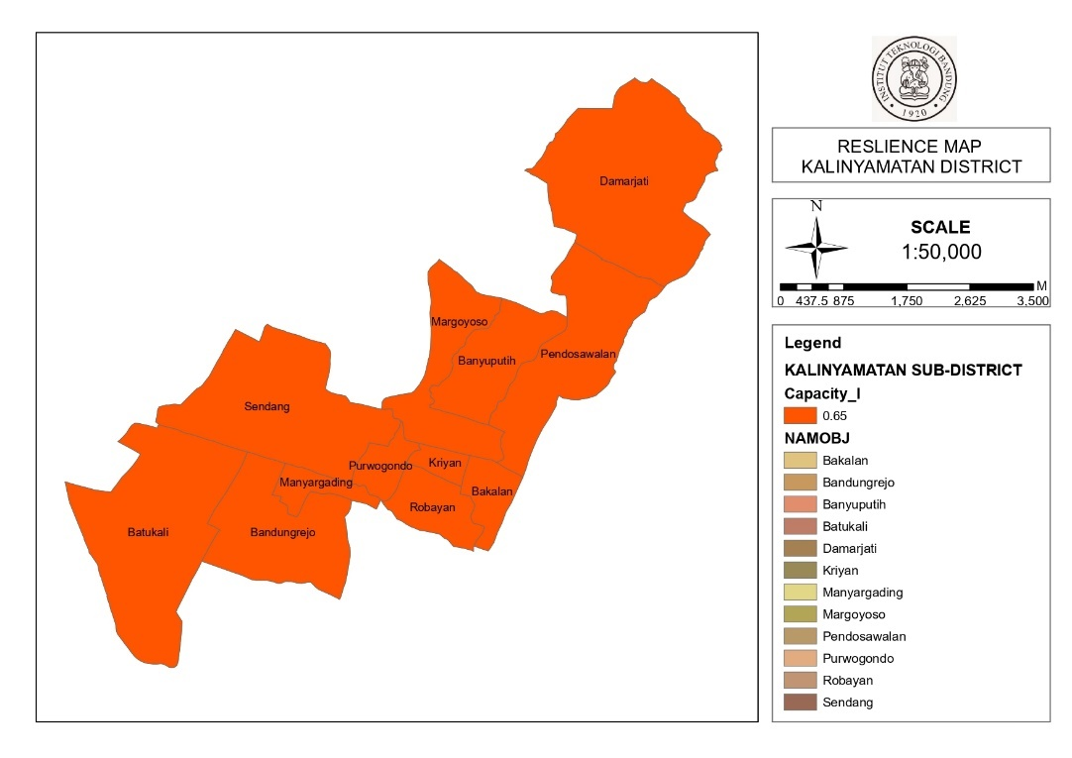

Figure 7 Vulnerability map in kalimanyatan district.
Figure 7 map in kalinyamatan district.

Risk Map
After calculated hazard map, vulnerability map and capacity map, with using formula from Regulation of the Head of the National Disaster Management Agency No. 02 of 2012 concerning General Guidelines for Disaster Risk Assessment [20] it showed from Table 8, the total risk calculated for risk map.

- Total risk.
No | Sub-District | Hazard | Vulnerability | Capacity | TOTAL
1 | Kriyan | 0.6667 | 0.2953 | 0.65 | 0.4100
2 | Bandungrejo | 0.6667 | 0.2840 | 0.65 | 0.4047
3 | Pendosawalan | 1 | 0.2830 | 0.65 | 0.4627
4 | Margoyoso | 0.6667 | 0.2983 | 0.65 | 0.4113
5 | Batukali | 0.6667 | 0.2742 | 0.65 | 0.4000
6 | Robayan | 0.6667 | 0.3017 | 0.65 | 0.4129
7 | Purwogondo | 0.6667 | 0.3084 | 0.65 | 0.4160
8 | Banyuputih | 0.6667 | 0.2952 | 0.65 | 0.4099
9 | Manyargading | 0.6667 | 0.2901 | 0.65 | 0.4075
10 | Darmajati | 1 | 0.2794 | 0.65 | 0.4607
11 | Sendang | 0.6667 | 0.2944 | 0.65 | 0.4096
12 | Bakalan | 0.6667 | 0.2839 | 0.65 | 0.4046

After getting the total risk, it can be seen from Figure 8 the Risk map for Flood Hazard generated by Dam Break in Kalinyamatan District.
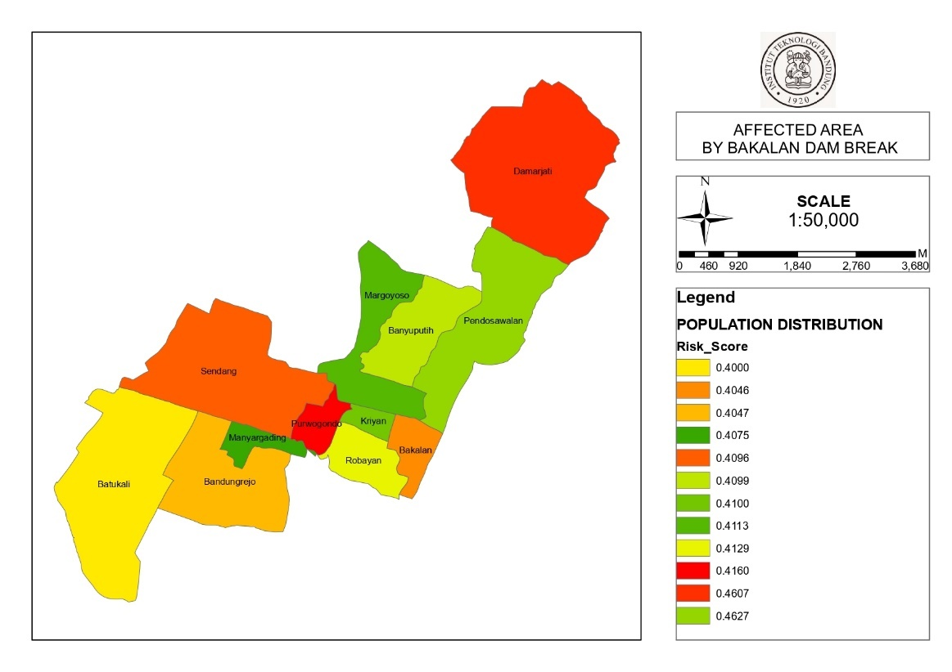

Figure 8 Risk map in kalinyamatan district.

Conclusion
The Bakalan Dam which was built in the Bakalan River, Jepara Regency has many useful functions, including meeting the needs of raw water, irrigation water and flood control. However, the dam will also have the potential to cause disaster, if the dam collapses. In this study, the dam collapse was analyzed using HEC RAS ​​2D and a hazard map was obtained in the Kalinyamatan area, Jepara Regency. Then the results are plotted in Arc GIS and the risk score index value is calculated based on the Regulation of the Head of the National Disaster Management Agency No. 02 of 2012 concerning General Guidelines for Disaster Risk Assessment, obtaining a score of hazard map, vulnerability map and capacity map. Some of the 12 villages in the Kalinyamatan area that were affected by flooding due to the dam collapse have mostly low and moderate level, but there are also 7 villages in the Kalinyamatan area that have moderate to high risk.

References
- Regional Regulation of Jepara Regency concerning Regional Medium-Term Development Plans, 2017.
- Che Ros F, Sidek L M, A Razad A Z, Nik Ibrahim N N, Ahmad M N, Dam Break Analysis For Hydroelectric Dam: Case Study Of Kenyir Dam, Terengganu, Malaysia Proceeding of International Seminar on Advances in Renewable Energy Technology (ISARET), 2009.
- Sammen, S.S, Mohamed, T.A, Ghazali, A.H, Sidek, L.M, El-Shafie, A., An Evaluation of Existent Methods for Estimation of Embankment Dam Breach Parameters, Natural Hazards, 87 (1), 545-566, 2017.
- Shahrim, M. F., F C Ros, Dam Break Analysis of Temenggor Dam Using HEC-RAS, The 7th AUN/SEED-Net Regional Conference on Natural Disaster (RCND), 2019.
- Cannata, M., & Marzocchi, R, Two-dimensional dam break flooding simulation: a GIS-embedded approach, Natural Hazards, 61(3), 1143–1159, 2011.
- Gogoaşe Nistoran, D. E., Gheorghe Popovici, D. A., Savin, B. A. C., & Armaş, I., GIS for Dam-Break Flooding Study Area: Bicaz-Izvorul Muntelui (Romania), Space and Time Visualisation, 253–280, 2016.
- Álvarez, M., Puertas, J., Peña, E., & Bermúdez, M., Two-Dimensional Dam-Break Flood Analysis in Data-Scarce Regions: The Case Study of Chipembe Dam, Mozambique, Water, 9(6), 432, 2017.
- Nabilah, R.A., et. al., Dam Break Analysis of Situ Gintung Dam Collapse Reconstruction, IOP Conf. Series: Earth and Environmental Science, 599, 2020.
- HEC-RAS. River Analysis System Hydraulic Reference Manual; Hydrologic Engineering Center US Army Corps of Engineer: Davis, CA, USA, 2016.
- Torimtubun A.T, Asmaranto R, Flood Analysis Due to the Collapse of the Banyukuwung Dam Using HEC-RAS, 2018.
- Pramono A, Juwono P.T, Asmaranto R, Flood analysis due to Wonorejo dam collapse using HEC-RAS, 2019.
- Muammar, A. Z. et al., Journal of Water Resources Technology and Engineering Vol. 1 No. 1, Analysis of the Malahayu Dam Collapse, Brebes Regency with the HEC-RAS Application and Calculation of Losses with the InaSAFE Application, p. 29-39, 2021.
- Palar, R.T, et al., Journal of Scientific Media Engineering Vol.11 No.2, Analysis of the Collapse of the Kuwil – Kawangkoan Reservoir Using the Assistance of the HEC-RAS Program, p. 113-122, 2021.
- Balogun, O.S, et. al., Nigerian Journal of Technology (NIJOTECH) Vol. 36, No. 1, Study and Analysis of Asa River Hypothetical Dam Break Using Hec-Ras, pp. 315 – 321, 2017.
- Sandi, C.; Nugroho, E. O.; Cahyono, M., Civil Engineering, Environmental, Disaster and Risk Management Symposium 2022, Analisis Risiko Dambreak Bendungan Jenelata dan Upaya Penanggulangannya, 2022.
- De Moel, H.; Bouwer, L.M.; Aerts, J.C.J.H. Uncertainty and sensitivity of flood risk calculations for a dikering in the south of the Netherlands. Sci. Total Environ, pp. 473–474, 224–234, 2014.
- Pu, J.H., Shao, S., Huang, Y., Hussain, K., Evaluations of SWEs and SPH numerical modelling techniques for dam break flows. Eng. Appl. Comput. Fluid Mech, pp. 544–563, 2013.
- Albano, R., et al., ISPRS Int. J. Geo-Inf, A GIS Tool for Mapping Dam-Break Flood Hazards in Italy, pp. 250, 2019.
- Jepara Regency Central Statistical Agency, Kalimatan sub-district in figures for 2022, 2022.
- Regulation of the Head of the National Disaster Management Agency, Regulation No. 02 of 2012 General Guidelines for Disaster Risk Assessment, 2012.
- Pratiwi, V.; Kusuma, M. S.B.; Kardhana, H.; Farid, M., International Journal Of GEOMATE, Nov., 2020, Vol.19, Issue 75, Experimental Study of Dam Break Flow Generated by The Flap Gate In Horizontal Channel, pp.19-26, 2020.

